Worksheet No. - 02

Aim/Overview of the practical

a) Create a Pivot table to quickly summarize large databases, Group within Pivot Tables.

b) Create multiple Pivot Tables on a single worksheet.
Objective: The objective of this experiment is to learn how to create Pivot Tables in Microsoft Excel to quickly summarize and analyze large datasets. It also aims to understand how to group data within Pivot Tables for better analysis and create multiple Pivot Tables on a single worksheet to compare and present information efficiently for effective decision-making.

Procedure/Algorithm/Code
Procedure
- Open the dataset in Microsoft Excel.
- Select the entire data range with headers.
- Click Insert → PivotTable and choose the desired location.
- Drag fields into Rows, Columns, Values, and Filters.
- Right-click a field and select Group to group data (if required).
- To create another Pivot Table, repeat Insert → PivotTable and place it in a different location on the same worksheet.
- Save the workbook after completing the analysis.

Raw Data Table:
Date | Salesperson | Region | Product | Category | Unit Sold | Sales Amount
05-Jan-26 | Aman | North | Laptop | Electronics | 5 | 250000
12-Jan-26 | Neha | South | Mobile | Electronics | 10 | 200000
20-Jan-26 | Rahul | East | Chair | Furniture | 15 | 75000
28-Feb-26 | Simran | West | Table | Furniture | 8 | 96000
10-Mar-26 | Aman | North | Mobile | Electronics | 12 | 240000
18-Mar-26 | Neha | South | Laptop | Electronics | 4 | 200000
05-Apr-26 | Rahul | East | Table | Furniture | 10 | 120000
15-Apr-26 | Simran | West | Chair | Furniture | 20 | 100000
08-May-26 | Aman | North | Laptop | Electronics | 6 | 300000
20-May-26 | Neha | South | Mobile | Electronics | 15 | 300000
10-Jun-26 | Rahul | East | Chair | Furniture | 18 | 90000
25-Jun-26 | Simran | West | Table | Furniture | 12 | 144000
07-Jul-26 | Aman | North | Mobile | Electronics | 14 | 280000
19-Jul-26 | Neha | South | Laptop | Electronics | 7 | 350000
09-Aug-26 | Rahul | East | Table | Furniture | 9 | 108000
22-Aug-26 | Simran | West | Chair | Furniture | 25 | 125000

Details for Sum of Sales Amount
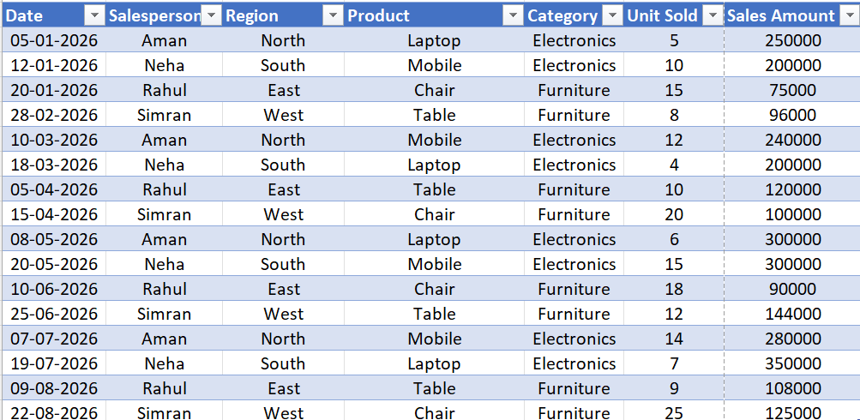
Pivot Table 1: Monthly Sales Analysis
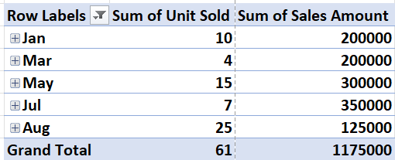
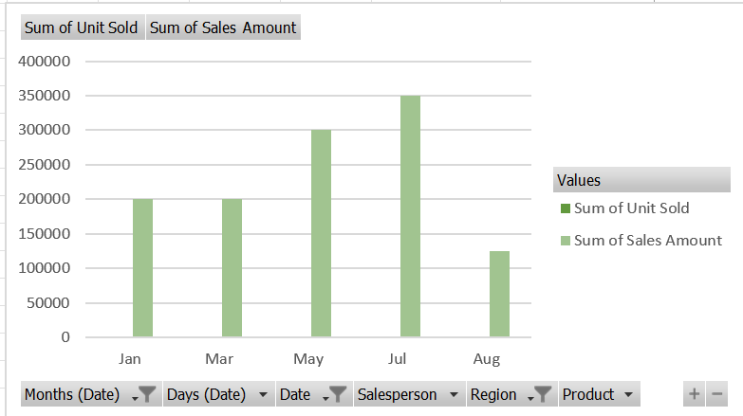

Pivot Table 2: Region-wise Sales Report
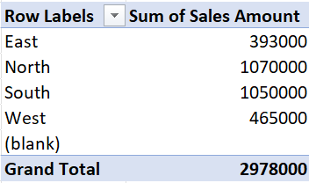
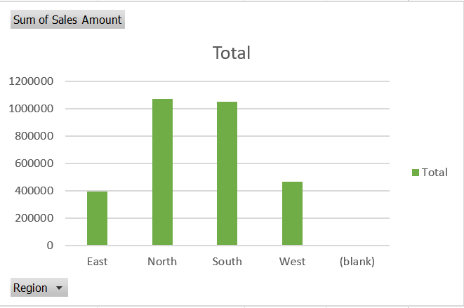
Learning outcomes (What I have learnt):
- Created Pivot Tables to summarize and analyze large datasets efficiently.
- Grouped data in Pivot Tables based on categories such as dates, regions, or products.
- Created multiple Pivot Tables on a single worksheet for comparative analysis.
- Filter and organize data to generate meaningful reports.

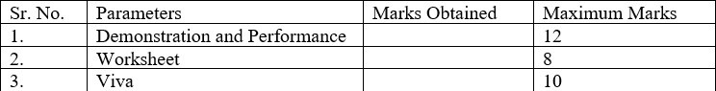
Evaluation Grid:

